Project Report

Bookie Nest

# **Introduction**

**Project Overview**

In today’s digital landscape, the way people discover, purchase, and enjoy books is rapidly evolving. With the rise of e-commerce and online reading platforms, readers now expect instant access to a wide range of literary content with personalized recommendations and a seamless browsing experience.

**Bookie Nest: Your Digital Bookstore Haven** is an innovative online platform built to enhance how users interact with books, authors, and fellow readers. Developed using the **MERN stack** (MongoDB, Express.js, React.js, and Node.js), Bookie Nest offers a responsive, scalable, and user-friendly solution for book lovers, casual readers, and collectors alike.

Unlike traditional bookstore websites that often offer only basic browsing and checkout, Bookie Nest places a strong emphasis on personalized user experience, community interaction, and advanced content filtering. With features such as AI-driven book recommendations, user reviews, reading lists, and a modern UI, the platform ensures that users can easily discover books aligned with their tastes and reading history.

Bookie Nest is accessible across multiple devices including smartphones, tablets, and desktops, ensuring a consistent and responsive experience. The platform supports user authentication, admin management of book inventories, and dynamic search and filter functionalities. With plans to support both e-books and physical copies, Bookie Nest caters to a diverse audience of book enthusiasts.

The system is designed to scale efficiently and handle increasing traffic and inventory without compromising performance. Security features such as JWT-based authentication and encrypted transactions help maintain a safe environment for both buyers and sellers.

Bookie Nest aims to be more than just a bookstore—it’s a digital reading hub where technology meets literature to bring stories closer to every reader.

**1.2 Purpose**

The primary purpose of **Bookie Nest** is to redefine the online book shopping and reading experience by solving common issues like lack of content discoverability, unengaging user interfaces, and limited interaction between readers and sellers. The platform is built to bridge the gap between modern readers’ needs and traditional online bookstore models.

**Key Objectives:**

**1. Enhanced Book Discovery:**

* Implement an AI-powered recommendation engine to suggest books based on user preferences, past purchases, and popular trends.
* Offer curated book collections, bestseller charts, and user-generated reading lists to reduce search time and improve user satisfaction.

**2. Seamless Shopping & Reading Experience:**

* Provide smooth browsing and checkout processes for both physical and digital books.
* Ensure cross-device compatibility so users can manage their library and wishlist from anywhere.

**3. Community and Social Interaction:**

* Enable users to write reviews, rate books, and engage in discussions with other readers.
* Integrate social sharing features to let users post their favorite reads on platforms like Instagram, Twitter, and Facebook.

**4. Secure and Scalable Infrastructure:**

* Use **JWT** for user authentication and **OAuth** for third-party login options (e.g., Google, Facebook).
* Leverage cloud storage and distributed database management for scalability and fast performance.

**5. Flexible Monetization and Payment Systems:**

* Offer a variety of purchase options including pay-per-book, bundles, and premium memberships for discounts or early access.

By focusing on these core pillars, **Bookie Nest** sets out to create a rich and immersive book-shopping ecosystem for a broad spectrum of users. Whether you’re a student, a casual reader, or a book collector, Bookie Nest offers tools and features tailored to meet your reading lifestyle.

# **Ideation Phase**

## ****2.1 Problem Statement****

In the current digital age, book lovers often face several challenges when trying to discover and purchase books online. Many existing platforms are cluttered, lack intuitive navigation, and offer limited personalization, making it difficult for users to find books that match their interests or reading habits. As a result, readers spend more time browsing through irrelevant listings rather than enjoying their reading experience.

Additionally, most online bookstores fail to offer smart recommendation systems, leading to poor content discovery and user disengagement. First-time buyers and casual readers often feel overwhelmed by vast catalogs with little to no guidance. Furthermore, features like wishlists, user reviews, and social interactions are either missing or underdeveloped, reducing user retention and satisfaction.

From a technical standpoint, issues like inconsistent UI responsiveness across devices, minimal mobile optimization, and basic security practices further hamper the user experience. Families and academic users also struggle with the lack of multi-profile support, reading history tracking, and parental controls to manage book selections for younger readers.

Finally, many users are deterred by inflexible payment options and unclear return policies. They seek affordable, user-friendly platforms that support both physical and digital books with a smooth and trustworthy checkout experience.

**Bookie Nest** aims to solve these challenges by offering a smart, personalized, and community-driven digital bookstore that puts user experience at the forefront. By integrating advanced recommendation systems, seamless device compatibility, secure transactions, and an intuitive UI, Bookie Nest provides a refreshing alternative to the current online book shopping experience—one that truly adapts to the reader’s lifestyle, preferences, and needs.

### Empathy map

An empathy map is a simple, easy-to-digest visual that captures knowledge about a user’s behaviours and attitudes. It is a useful tool to helps teams better understand their users.Creating an effective solution requires understanding the true problem and the person who is experiencing it.

### EMPATHY MAP

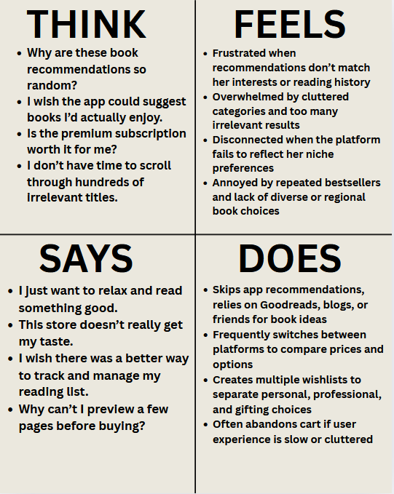

* 1. **Brainstorming & Idea Prioritization**

Brainstorming at Bookie Nest creates a free and open space where team members are encouraged to participate in creative thinking to solve problems. Emphasizing quantity over perfection, unique and unconventional ideas are welcomed and built upon collaboratively.

Even when working remotely, this approach allows every participant to contribute, helping shape new concepts that improve the user experience, expand features, and enhance the future of our online bookstore platform.

Use this template in your brainstorming sessions to spark creativity, drive innovation, and develop solutions that help Bookie Nest grow.

**Step-1: Team Gathering, Collaboration and Select the Problem Statement**

**Team ID:** SWTID1743696165

Team Members:

* **Team member:** Baibhav Kumar Singh
* **Team member:** Harshal Rajendra Patil
* **Team member:** Anurag Anand
* **Team member:** Akhand Pratap Singh

**Problem Statement:**

The current challenge for many online bookstores lies in delivering highly relevant book suggestions that align with individual reading preferences, while also ensuring a seamless and intuitive browsing experience. Our goal is to integrate AI-driven recommendations and interactive features—such as user reviews, ratings, and genre-based curation—to improve user satisfaction and foster long-term reader engagement.

**Step-2: Brainstorm, Idea Listing and Grouping**

**Ideas Generated:**

* AI-based personalized book recommendations
* Virtual reading rooms for shared reading experiences
* Multi-device sync for bookmarks and reading history
* Adjustable text settings for accessibility
* Voice search for finding books quickly

**Idea Grouping:**

* **User Engagement:** Virtual reading rooms, multi-device sync
* **AI & Personalization:** AI-based book recommendations, voice search
* **Accessibility Features:** Adjustable text settings

**Step-3: Idea Prioritization**

**Prioritized Ideas:**

1. **AI-based personalized book recommendations** – Enhancing book discovery with intelligent suggestions.
2. **Virtual reading rooms** – Promoting community reading and discussion.
3. **Adjustable text settings** – Improving accessibility for diverse readers.

**Next Steps:**

* Assign development responsibilities across the team
* Research and integrate AI-driven book recommendation algorithms
* Design and implement virtual reading room functionality
* Add and test accessibility features (font size, contrast)
  + Collect user feedback and iterate based on usage patterns

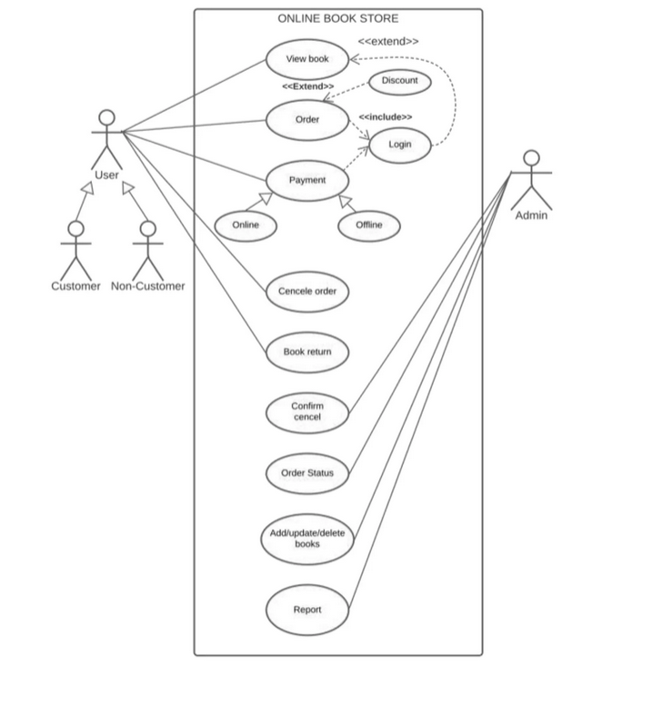

# **3.** **Requirement Analysis**

## Customer Journey map

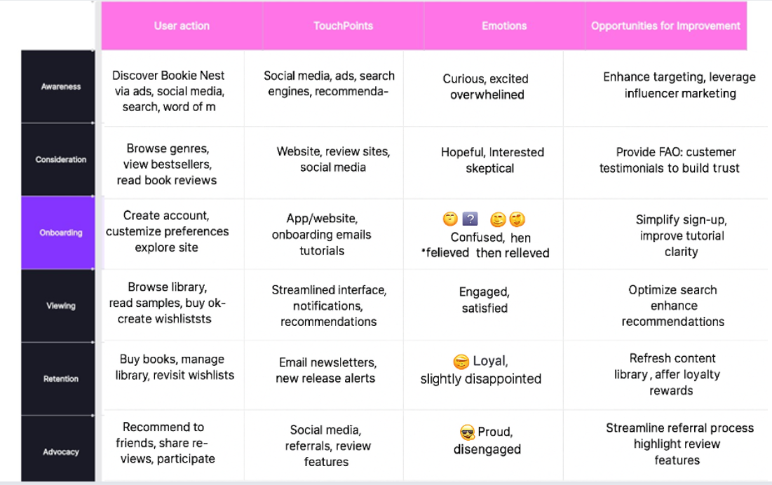

## Data Flow Diagram

### 3.2.1 Data flow diagrams

A Data Flow Diagram (DFD) is a traditional visual representation of the information flows

within a system. A neat and clear DFD can depict the right amount of the system requirement graphically. It shows how data enters and leaves the system, what changes the information, and where data is stored.

**Example:**

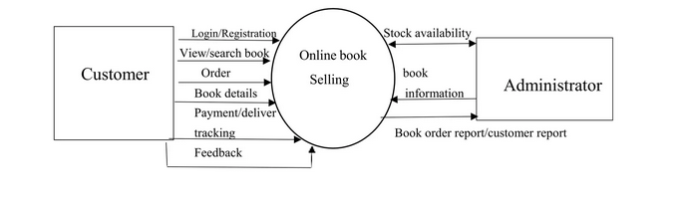

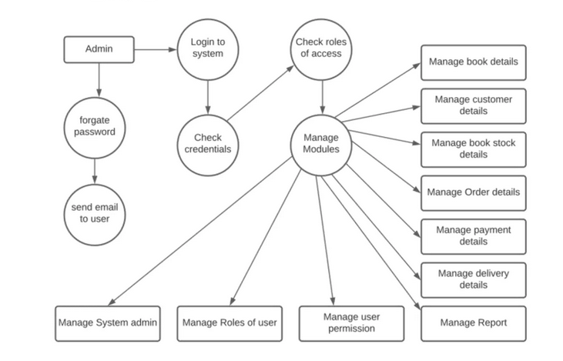

## Technology task

### ****Technical Architecture****

We’ll use a scalable cloud-deployed 3-tier architecture (Client → Server → Database/Storage) tailored for an online bookstore:

* **Client:** ReactJS-based responsive web interface for browsing, purchasing, and reading books
* **Server:** Node.js backend using Express with RESTful APIs for handling requests, authentication, and business logic
* **Database:** MongoDB Atlas for storing user profiles, books, reviews, orders, and wishlists
* **External APIs:** Google Books API or Open Library API to enrich book metadata
* **Authentication:** Google OAuth, LinkedIn, and email/password-based authentication
* **File Handling:** Digital book downloads and previews managed through cloud storage (e.g., AWS S3 or equivalent)

**Table-1: Components & Technologies**

|  |  |  |  |
| --- | --- | --- | --- |
| S.No | Component | Description | Technology |
| 1 | User Interface | Web-based user interface | ReactJS, HTML, CSS, JavaScript |
| 2 | Application Logic- 1 | User authentication & profile  management | Node.js, Express.js |
| 3 | Application Logic- 2 | Content browsing, streaming logic | Node.js |
| 4 | Application Logic- 3 | Admin panel logic | Node.js, Express.js |
| 5 | Database | Stores users, subscriptions, metadata | MongoDB Atlas (NoSQL) |
| 6 | Cloud Database | Cloud-hosted DB | MongoDB Atlas |

|  |  |  |  |
| --- | --- | --- | --- |
| 9 | External API-2 | Authentication | Google OAuth, LinkedIn OAuth |
| 11 | Infrastructure | Hosting and deployment | Netlify |

**Table-2: Application Characteristics**

|  |  |  |
| --- | --- | --- |
| S.No | Characteristics | Description |
| 1 | Open-Source Frameworks | MERN stack, Bootstrap/Tailwind |
| 2 | Security Implementations | JWT, OAuth2, HTTPS,  Role-based Access, Helmet.js, CORS |
| 3 | Scalable Architecture | Microservices-ready, 3-tier separation, containerized  services |
| 4 | Availability | Hosted on scalable cloud platforms with load  balancing |
| 5 | Performance | Caching, CDN, efficient DB queries, code splitting, lazy loading |

# **4. Project Design**

* 1. Problem Solution Fit

### ****Problem – Solution Fit canvas for Bookie Nest: Online Bookstore Platform****

The Problem-Solution Fit refers to identifying a genuine pain point for book lovers and readers, and ensuring that the solution provided by Bookie Nest effectively resolves those problems. This framework helps developers, entrepreneurs, and stakeholders understand user behavior and tailor the platform accordingly.

### ****Purpose:****

* **Solve key problems** faced by readers such as poor recommendations, lack of regional or academic content, and limited access to verified reviews.
* **Speed up user adoption** by aligning with the natural behavior of users—browsing by interest, searching by title/author, and wishlisting books.
* **Refine communication and marketing** by focusing on readers' priorities—value for money, curated lists, and fast delivery or download.
* **Build trust and consistency** through features like genuine reviews, verified ratings, and user profiles with history.
* **Understand user behavior** to enhance their reading and shopping experience, whether casual browsers or academic learners.

**CUSTOMER SEGMENT(S) (CS)**

* Book readers (students, casual readers, professionals)
* Users looking for personalized book suggestions
* Buyers seeking regional, academic, or genre-specific titles
* Readers who prefer a smooth, ad-free browsing and purchase experience
* Independent authors and small publishers

**PROBLEMS / PAINS (PR)**

* Difficulty in discovering books that match their taste
* Generic or inaccurate recommendations
* Lack of genuine user reviews or sample content
* Tedious checkout experience, especially on mobile
* No wishlist or save-for-later functionality

**PROBLEMS / PAINS (PR)**

* Difficulty in discovering books that match their taste
* Generic or inaccurate recommendations
* Lack of genuine user reviews or sample content
* Tedious checkout experience, especially on mobile
* No wishlist or save-for-later functionality

**TRIGGERS TO ACT (TR)**

* A friend or influencer recommends a book
* Academic/reading needs arise (exams, projects, interests)
* User wants to explore a new genre or series
* Book launch or trending titles grab attention
* Discounts or deals on favorite authors/genres

**EMOTIONS (EM)**

* **Before**: Confused, overwhelmed, frustrated by cluttered stores or irrelevant books
* **After**: Fulfilled, curious, inspired, excited to read and explore more

**AVAILABLE SOLUTIONS (AS)**

* Other online bookstores (Amazon, Flipkart, local apps)
* Blogs and YouTube for book reviews
* Bookstagram and Reddit recommendations
* Brick-and-mortar bookstores

**CUSTOMER LIMITATIONS (CL)**

* Budget limitations (especially students)
* Limited access to rare or regional titles
* Poor mobile experience or low digital literacy
* Preference for physical books over eBooks

**BEHAVIOR (BE)**

* Readers often create lists or follow trends (TBRs)
* Tend to stick to favorite genres/authors
* Influenced by peer reviews or BookTok/Bookstagram
* Value personalized recommendations and collections

**CHANNELS OF BEHAVIOR (CH)**

* **Online**: Bookie Nest app/website, social media, email newsletters, online book clubs
* **Offline**: Word-of-mouth, book fairs, libraries, academic references

**ROOT / CAUSE OF PROBLEM (RC)**

* Other platforms lack focused personalization
* Poor UI/UX in mobile-first reading communities
* Limited features for community engagement and real-time book reviews
* Over-reliance on algorithmic or bestseller listings

**YOUR SOLUTION (SL)**

* AI-based personalized book recommendations based on genre, reading history, and reviews
* User-curated reading lists, favorites, and sharing options
* Seamless mobile-first browsing and checkout
* Verified ratings and review system
* Community features like reading groups, bookmarks, and author Q&A

### Proposed Solution Template

|  |  |  |
| --- | --- | --- |
| **S.No.** | **Parameter** | **Description** |
| 1. | **Problem Statement** | Readers struggle to find and manage books efficiently due to the lack of personalized recommendations, trusted reviews, and easy navigation within existing platforms. |
| 2. | **Idea / Solution Description** | **Bookie Nest** is an intelligent and user-friendly online bookstore platform that offers personalized book recommendations, verified user reviews, and seamless navigation. With features like smart search, genre filters, wishlists, and community ratings, it helps users discover, manage, and enjoy books tailored to their interests—all in one place. |
| 3. | **Novelty /**  **Uniqueness** | Unlike typical online bookstores, **Bookie Nest** offers a highly personalized reading experience with AI-driven recommendations, community-driven reviews, and user-curated reading lists. It also features a customizable, open-source platform suitable for book clubs, educational institutions, and niche literary communities. |
| 4. | **Social Impact / Customer Satisfaction** | Promotes meaningful user engagement through book reviews and ratings, empowers independent authors and educators to share their work, and enhances reading experiences with personalized recommendations and seamless access to a diverse library. |

**4.3 Solution Architecture:**

The architecture for Bookie Nest is designed to ensure scalability, personalization, performance, and

Smooth user experience.

**1. Service Layer – Microservices Components**

* **User Service** – Manages registration, login, profile updates, and user data.
* **Book Content Service** – Handles book data, previews, uploads, metadata, and categorization.
* **Subscription Service** – Manages premium access, payment gateway integration, and billing.
* **Search Service** – Enables efficient book search and filtering using tags, genres, and keywords.
* **Recommendation Service** – Provides personalized book suggestions based on user preferences, history, and ratings.
* **Analytics Service** – Tracks user behavior, reads, reviews, and other engagement metrics.
* **Media Processing Service** – Handles preview generation (PDF/EPUB previews), cover rendering, and format compatibility.
* **Notification Service** – Sends alerts for new book releases, payment updates, and recommendations.
* **Admin Service** – Allows content management, analytics dashboards, user moderation, and access control for admins.

**2. Data Layer – Storage and Caching**

* **MongoDB** – Primary data storage for user data, book metadata, subscriptions, and reviews.
* **Redis** – In-memory caching to speed up frequently accessed data such as search history or trending books.
* **Elasticsearch** – Powering the fast search and smart recommendations.
* **AWS S3 / Distributed File Systems** – Secure storage of book files, previews, and cover images.

**3. Infrastructure & DevOps Layer**

* **Containerization (Docker)** – Ensures consistent deployment of services across environments.
* **Orchestration (Kubernetes)** – Automates scaling, deployment, and management of containerized services.
* **CI/CD Pipelines** – Streamlined development workflow for testing and deploying new features.
* **Monitoring & Logging** – Tracks system performance, logs errors, and provides real-time analytics for maintenance.
* **Security Measures** – Role-based access, HTTPS, JWT, OAuth, and GDPR-compliant data handling.

**4. External Integrations & Delivery Optimization**

* **External APIs** – Book metadata, author profiles, or third-party review sources.
* **CDN & Edge Infrastructure** – For fast content delivery, especially previews and cover images, ensuring minimal latency.

**5. PROJECT PLANNING and SCHEDULING**

**5.1 Project planning**

**Product Backlog, Sprint Schedule, and Estimation**

|  |  |  |  |  |  |  |
| --- | --- | --- | --- | --- | --- | --- |
| Sprint | Functional  Requirement (Epic) | User Story  Number | User Story / Task | Story Points | Priority | Team Members |
| Sprint-1 | Registration | USN-1 | As a user, I can register for the application by entering my email,  password, and confirming my  password. | 2 | High | Harshal, Anurag |
| Sprint-1 | Registration | USN-2 | As a user, I will receive a confirmation email once I have registered for the  application. | 1 | High | Harshal, Anurag |
| Sprint-2 | Registration | USN-3 | As a user, I can register for the application through  google. | 2 | Low | Harshal, Anurag |
| Sprint-1 | Registration | USN-4 | As a user, I can register for the application through Gmail. | 2 | Medium | Harshal, Anurag |
| Sprint-1 | Login | USN-5 | As a user, I can log into the application by  entering email  password. | 1 | High | Harshal, Anurag |
| Sprint-2 | Login | USN-6 | As a user, I get an error message for invalid credentials  while logging in. | 2 | Medium | Baibhav,  Akhand |
| Sprint-2 | Dashboard | USN-7 | As a user, I can see the home page/dashboard after login. | 3 | High | Baibhav,  Akhand |

|  |  |  |  |  |  |  |
| --- | --- | --- | --- | --- | --- | --- |
|  |  |  |  |  |  |  |
| Sprint-2 | Dashboard | USN-8 | As a user, I can search for a book using a search bar. | 2 | Medium | Anurag, Akhand, Harshal, Baibhav |
| Sprint-2 | Dashboard | USN-9 | As a user, I can filter books by genre or rating. | 3 | Medium | Harshal, Baibhav |
| Sprint-2 | Dashboard | USN-10 | As a user, I can view detailed information and reviews of a  Selected book. | 2 | High | Harshal, Baibhav |

# **6. FUNCTIONAL AND PERFORMANCE TESTING**

### 6.1 User Acceptance Testing

**Project Overview**  
**Project Name:**

Bookie Nest: Your Smart Book Management Hub  
**Project Description:**

A MERN-based digital library platform that enables users to explore, preview, and review books with personalized features and seamless navigation.  
**Project Version:** 1.0  
**Testing Period:** 01-April-2025 to 10-April-2025

**Testing Scope:**

* User Registration
* User Login
* Book Preview
* Payment Integration
* Search Functionality
* Add Review
* User Profile Update
* Notification & Alerts

**Testing Environment: Local Machine**

**Test Cases:**

|  |  |  |  |  |  |
| --- | --- | --- | --- | --- | --- |
| **Test Case ID** | **Test Scenario** | **Test Steps** | **Expected Result** | **Actual Result** | **Pass/Fail** |
| TC- 001 | User  Registration | 1. Open Sign-up  Page 2. Enter  details 3. Submit | Account successfully created | Account successfully created | Pass |
| TC- 002 | User Login | 1. Open Login   Page 2. Enter  credentials 3. Submit | User logged in successfully | User logged in successfully | Pass |
| TC- 003 | Book Preview | 1. Select a Book 2. Click Preview | Preview Successful | Preview Successful | Pass |
| TC- 004 | Payment | 1. Choose book 2. Enter payment details 3. Confirm | Payment processed successfully | Payment processed successfully | Pass |
| TC- 005 | Search  Functionality | 1. Enter keyword 2. Click search | Relevant results displayed | Relevant results displayed | Pass |
| TC- 006 | Add Review | 1. Select book 2.   Enter comment 3. Post | Comment appears below book | Comment appears below book | Pass |
| TC- 007 | User Profile Update | 1. Go to profile 2.   Edit details 3. Save | Profile updated successfully | Profile updated successfully | Pass |
| TC- 008 | Notification Alerts | 1. Perform an   action (like new upload) | Notification received | Notification received | Pass |

**Bug Tracking:**

|  |  |  |  |  |  |
| --- | --- | --- | --- | --- | --- |
| **Bug ID** | **Bug Description** | **Steps to reproduce** | **Severity** | **Status** | **Additional feedback** |
| BG- 001 | No critical issues found | N/A | N/A | Closed | System functions as expected |

**Sign-off:**

**Tester Name**: Team  
**Date**: 10-April-2025

Notes**:**

* All test cases have passed successfully.
* No critical issues were found during testing.
* **Bookie Nest** is ready for deployment.

# **7. Results**

**Output Screenshots**

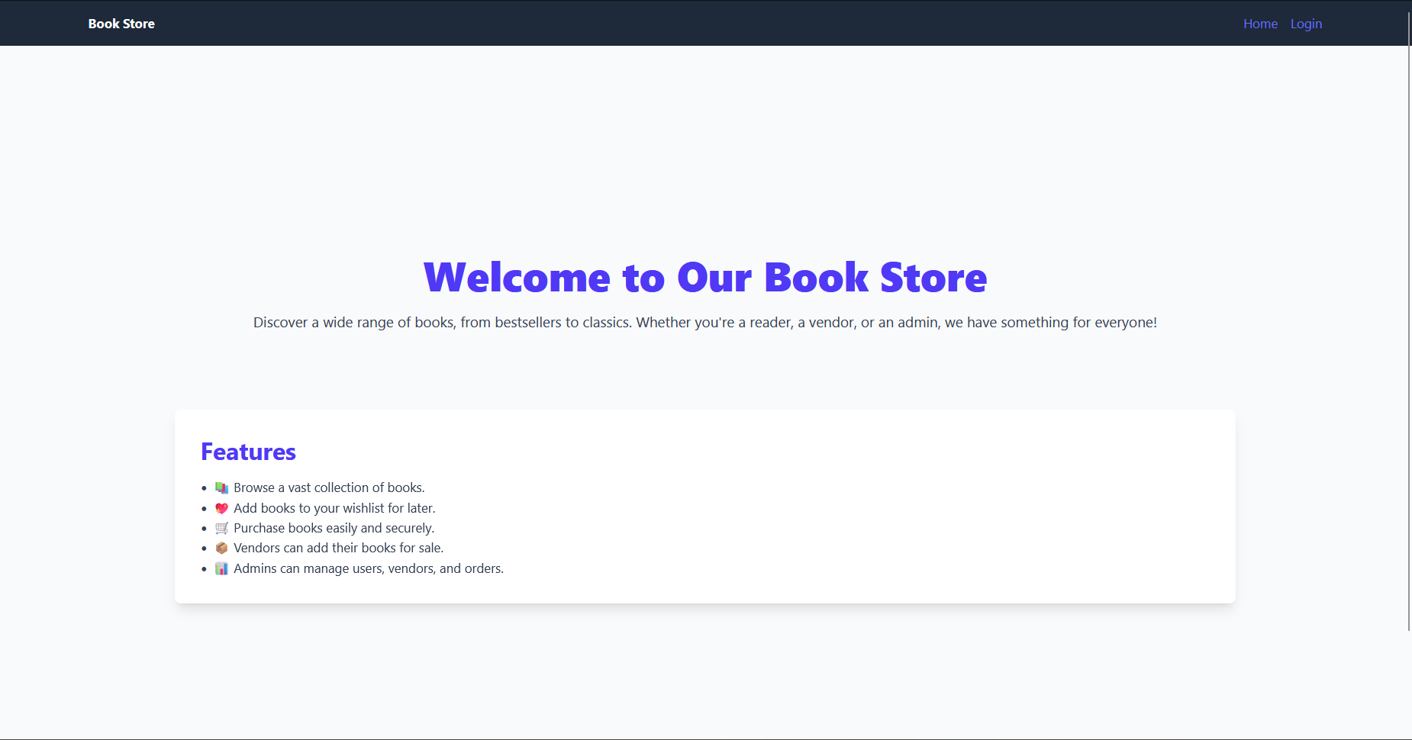

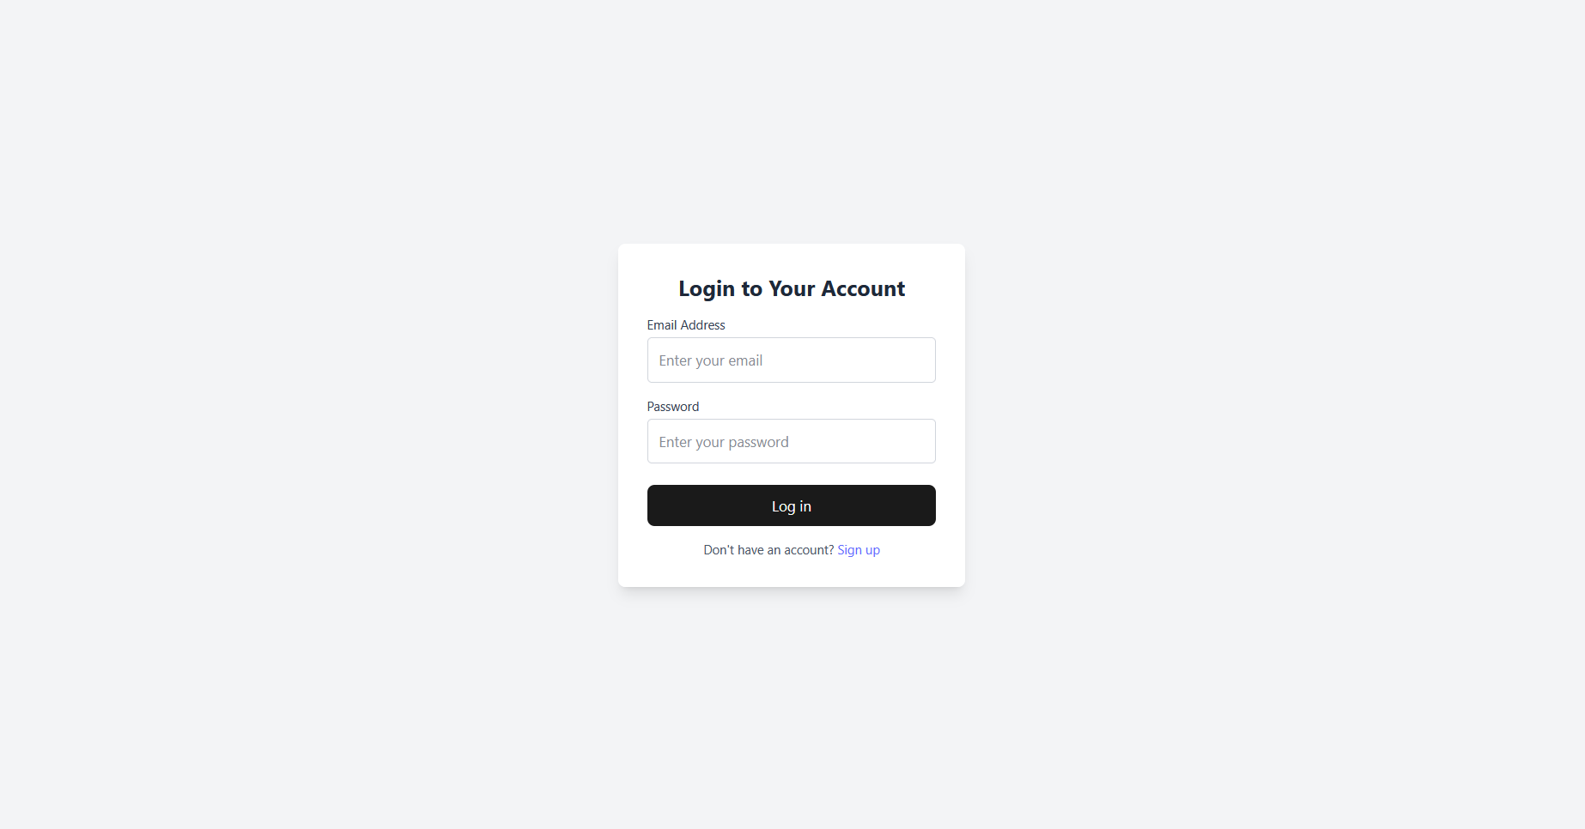

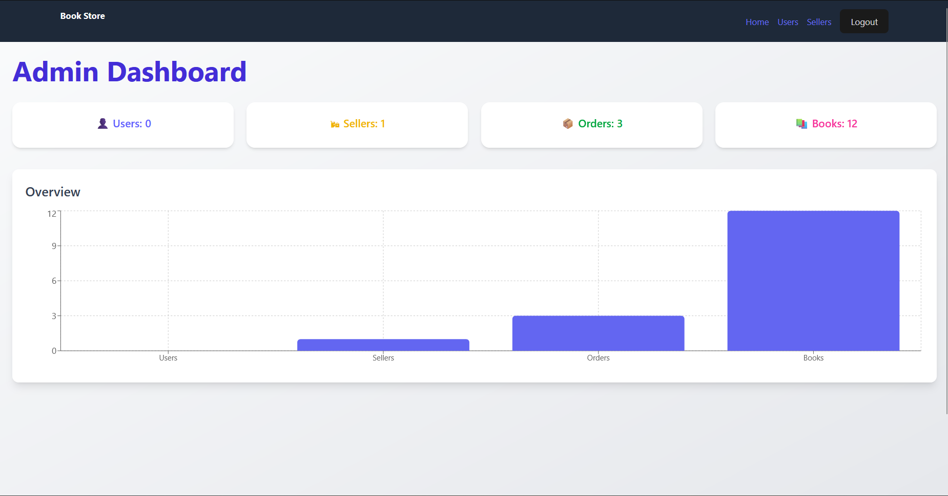

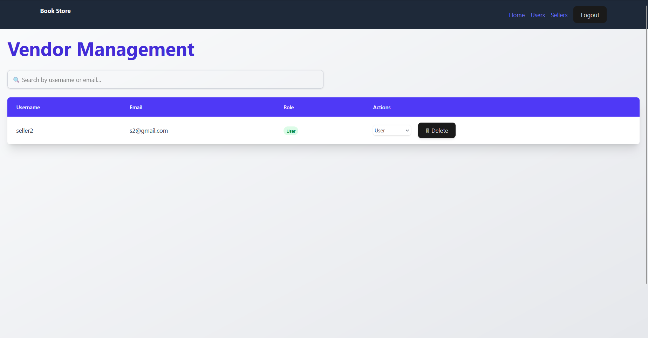

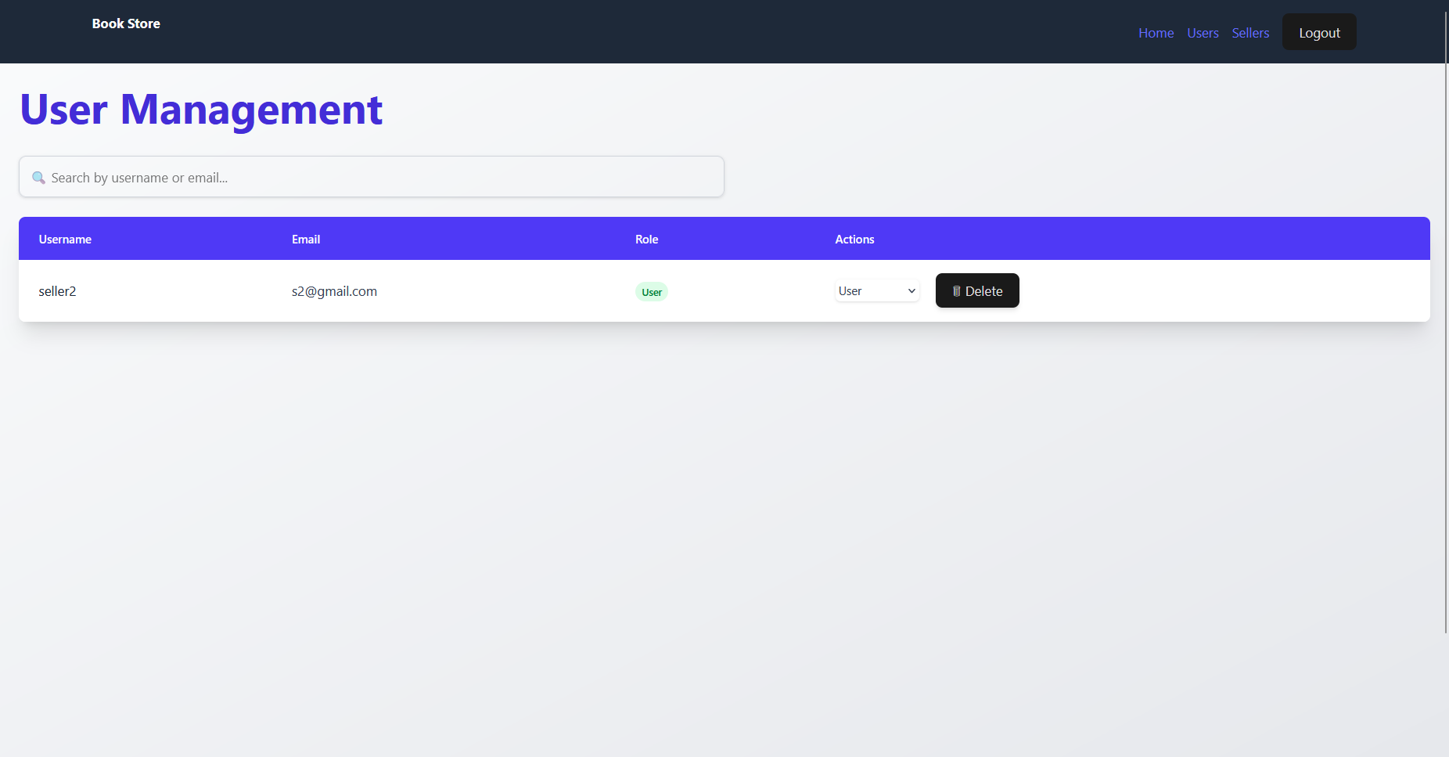

# **8. ADVANTAGES s DISADVANTAGES**

# **Advantages**

# **Scalable Architecture**: Built using the MERN stack, which supports easy expansion with features like recommendation engines or analytics tools.

# **Cloud Deployment**: Hosted on services like Vercel, Render, and MongoDB Atlas, making it highly available and easy to scale.

# **Responsive UI**: The React-based frontend ensures a smooth, intuitive, and dynamic user experience.

# **Third-party Integrations**: Can be integrated with book data providers such as Google Books API or Open Library for real-time information.

# **Flexible Authentication**: Offers multiple sign-in methods, including email/password, Google, and LinkedIn, enhancing user convenience.

# **Review & Wishlist Features**: Users can review books, create wishlists, and save favorites for a personalized reading experience.

# **Secure Platform**: Implements JWT, OAuth, HTTPS, and role-based access control to ensure user and data security.

# **Admin Dashboard**: Admins can manage books, users, reviews, and platform analytics easily from a centralized panel.

# **Community Building Potential**: Has the potential to evolve into a social platform with features like book clubs, discussion forums, or reading circles.

**Disadvantages**

* **Initial Setup Complexity:** Configuring APIs, authentication, and cloud services may require technical expertise and time.
* **API Dependency:** Relying on third-party book APIs may cause issues if services are down or rate-limited.
* **Monetization Challenges:** Adding features like paid eBooks or subscriptions requires additional legal and technical considerations.
* **Limited Offline Support:** Without specific offline features, users can't access saved content without internet.
* **Data Privacy Concerns:** Requires compliance with data protection regulations like GDPR when handling user data and activity.
* **Admin Panel Security:** Needs strong protection to avoid unauthorized access or misuse of platform controls.
* **Content Licensing Issues:** Hosting or selling books could face copyright and licensing challenges if not managed properly.

# **9. Conclusion**

The successful development and testing of **Bookie Nest: Your Ultimate Digital Bookstore Platform** mark a significant milestone in delivering a feature-rich, scalable, and reader-centric experience. From the beginning, this project set out to build an intuitive platform that simplifies book discovery, offers personalized recommendations, and fosters an engaging reading community.

Through detailed planning, agile development, and thorough testing, we ensured that the platform meets both functional and performance standards. Leveraging the power of the MERN stack, a robust backend API system, and a scalable MongoDB database, Bookie Nest is built to handle high user volumes while delivering a seamless and responsive experience.

Moreover, **User Acceptance Testing (UAT)** validated all critical features including user authentication, book management, review system, wishlists, and secure transactions. With successful test case execution across the board, Bookie Nest is fully ready for launch and public use.

Looking ahead, continuous monitoring, iterative updates, and feedback-driven improvements will keep the platform evolving with user needs. **Bookie Nest is set to redefine the online reading and book-buying experience**—creating a space where readers can discover, engage, and grow their personal libraries effortlessly.

**10. Future Scope**

**Bookie Nest** is just the beginning of a smart, immersive digital reading experience. As technology and reader expectations continue to evolve, the future scope of our platform promises limitless opportunities to enhance how people discover, read, and interact with books.

* **AI-Powered Book Recommendations**  
  In the future, Bookie Nest will implement advanced machine learning algorithms to provide hyper-personalized book suggestions based on user reading history, genre preferences, mood, and even reading pace—making every user’s library uniquely tailored.
* **Multi-Language and Regional Literature Support**  
  To cater to a global audience, we plan to introduce support for books in multiple languages, regional authors, and translated works, making literature more accessible and inclusive for diverse readers.
* **Interactive Reading and Live Book Events**  
  Future updates will introduce features like interactive book formats (e.g., choose-your-path stories), live author sessions, and virtual book clubs where users can engage in real-time discussions.
* **Advanced Security and User Privacy**  
  As digital reading grows, so does the need for security. Bookie Nest will integrate blockchain for digital rights management and enhance encryption protocols to ensure secure purchases, private reading data, and copyright protection.
* **Cross-Platform Reading Experience**  
  We aim to launch native applications for Android, iOS, tablets, and e-readers to ensure a seamless and unified reading experience—whether users are at home or on the go.
* **Community and Social Reading Features**  
  Bookie Nest will evolve into a social platform for readers with features like group reading, comments on book chapters, discussion threads, and peer-to-peer recommendations, fostering a vibrant reading community.
* **Cloud-Native Scalable Architecture**  
  To ensure fast performance and availability for all users, Bookie Nest will fully adopt cloud-native infrastructure using technologies like Docker, Kubernetes, and cloud providers like AWS or GCP.
* **Marketplace and Self-Publishing Tools**  
  Bookie Nest will empower authors with a dedicated self-publishing portal, monetization options, analytics, and reader feedback tools—turning the platform into a hub for both readers and creators.

# **11. Appendix**

Project GitHub link

<https://github.com/HarshalRajendraPatil/Book-Store-Project>

Project Demo Link

<https://drive.google.com/file/d/1d5pAry0RgAC2xTd7QA59fKnNHiUHbPIr/view?usp=sharing>

Documentations Drive Link

<https://drive.google.com/drive/folders/1gotxuY7dUE6GkRglJxDBjoaZM5vv-xBg?usp=sharing>